
Business Proposal
Greenfield Local Hub


Table of Contents
Research 2
Business Context 3
Project Aim 5
Functional Requirements 6
Non-Functional Requirements 7
Hierarchy Diagram 9
UI Considerations 9
Security Considerations & Risk Mitigation 10
Risk Matrix 10
Legal and Regulatory Guidelines 11

Research

robertsfarmshop.co.uk
www.beckettsfarm.co.uk
moseleyfarmersmarket.org.uk

Business Context

  - Producer Information & Local Benefits
  - Many competitors in the local farming and food producing industry fail to clearly provide detailed information in their digital solution. They missed to mention who their producers are, as well as the methods they have used, and they also fail to bring up all the benefits of buying locally. This results in customers being hesitant, the connection and trust with the customer reduces, abandoned shopping carts or even preferring to go shop from competitors. Therefore, the client, Greenfield Local Hub has requested for the digital solution to include all the important information needed. This is for customers to have a more in-depth idea of the local hub and what they strive for, but also to convey a message to society on how we must support the locals to boost the economy, so the money stays within the community. By buying locally, it supports small businesses and new jobs are created, it also helps the environment by reducing transport emissions. Including this information in the solution, will encourage customers to buy locally and help small businesses, it will also enhance the user experience and lead to higher revenue. Greenfield Local Hub will then become credible in the community, securing a strong position in the industry.

  - Product Listings with Pricing & Availability
  - The client
  - Order Placement (Collection or Delivery)

  - Customer Account & Order History

  - Producer Stock & Product Management Dashboard

  - Order Management, Scheduling & Tracking

  - Loyalty Scheme & Special Offers

  - Accessibility Features
  - The client

Project Aim

These are the essential requirements that the client would like to develop and include in the digital solution:
- provide information about the producers, their methods and the benefits of buying locally
- allow customers to view products with transparent pricing and availability
- allow customers to place orders for collection or delivery
- allow customers to manage their account and view order history
- provide a dashboard to enable producers to manage stock levels, update product details and view orders.
- order management, scheduling and tracking features
- a loyalty scheme that provides discounts and special offers
- accessibility features to support a wide range of users

Functional Requirements

Personas:
- Tom is a local farmer that sells his products at Greenfield Local Hub, he needs a simple producer dashboard that allows him to update his stock levels, update his products details, and view all his orders while working on the farm.

- Merinda is in her late 60s and has trouble walking so she prefers to place orders for delivery. Unfortunately, she has weak vision so she needs clear, visible pricing and product information. Therefore, accessibility features are essential for her.

- Jack is a customer in his 20s that regularly buys fresh local products for his family. As a regular customer he would appreciate a loyalty scheme that occasionally gives him discounts and special offers.

Functional Requirement | User Story | User Acceptance Criteria | Justification
Register | As Tom I want to register an account so that I can sell my products online and expand my business. | - Find the homepage  - Select register from the navigation  - Navigate to register page  - Enter a valid email address  - Enter a strong password  - Re-enter the password  - Correct any invalid inputs  - Submit registration form  - Receive confirmation message  - Be redirected to log in page | For Tom registering an account is important in order for him to be able to sell his products in the digital solution. A specialised producer account in is needed since he will be a producer that sells products. The features and functionality he has access to, would be different to a customers features. Registering is important so that all the data he adds is saved to a personalised account that he can access again whenever he wants.
Register | As Merinda I want to register an account so that I can place digital orders for delivery. | - Find the homepage  - Select register from the navigation  - Navigate to register page  - Enter a valid email address  - Enter a strong password  - Re-enter the password  - Correct any invalid inputs  - Submit registration form  - Receive confirmation message  - Be redirected to log in page
Register | As Jack I want to register an account so that I can access all the features of the website. | - Find the homepage  - Select register from the navigation  - Navigate to register page  - Enter a valid email address  - Enter a strong password  - Re-enter the password  - Correct any invalid inputs  - Submit registration form  - Receive confirmation message  - Be redirected to log in page
Log In | As Tom I want to log in to my account so that I can access the producer dashboard and manage my products, view orders and edit the stock levels. | - Find the homepage  - Select Log in from the navigation bar  - Enter valid credentials  - Correct any invalid inputs  - Log in successfully
Log In | As Merinda I want to log in to my account so that I can view my order history and reorder the same order. | - Find the homepage  - Select Log in from the navigation bar  - Enter valid credentials  - Correct any invalid inputs  - Log in successfully
Log In | As Jack I want to log in to my account so that I can access my personalised saved data. | - Find the homepage  - Select Log in from the navigation bar  - Enter valid credentials  - Correct any invalid inputs  - Log in successfully
Account Information | As Jack I want to view my account information so that I can change the delivery address. | - Find the homepage  - Make sure you are logged in  - Navigate to account icon  - View current profile details  - Select edit profile option  - Update delivery address  - Validate updated information  - Save changes  - Receive confirmation message
Account Information | As Tom I want to view my account information so that I can check my personal information is accurate. | - Find the homepage  - Make sure you are logged in  - Navigate to account icon  - View current profile details
Account Information | As Merinda I want to view my account information so that | - Find the homepage  - Make sure you are logged in  - Navigate to account icon  - View current profile details  - Select edit profile option  - Update delivery address  - Validate updated information  - Save changes  - Receive confirmation message
Order History | As Merinda I want to view my order history so that I can reorder products that I liked. | - Find the homepage  - Make sure you are logged in  - Navigate to account icon  - Find order history  - Click re-order  - Previous order products sent to the shopping cart  - Be redirected to shopping cart
Order History | As Jack I want to view my order history so that I can make sure the products I got delivered are the exact same as ordered. | - Find the homepage  - Make sure you are logged in  - Navigate to account icon  - Find order history  - View latest order  - Check all the items are correct
Product listings with pricing and availability | As Merinda I want to view products and their availability so that I
Product listings with pricing and availability | As Merinda I want to view products and their availability so that I
Order Placement, collection or delivery | As Merinda I want to place an order for delivery so that I
Producer information and local benefits | As Jack I want to place an order for collection so that I
Producer stock | As Tom I want to manage the products stock level so that I
Product Management Dashboard | As Tom I want to update product details so that I
Order Management | As Tom I want to view customer orders so that I
Loyalty Scheme | As Jack I want to get discounts and special offers after purchasing so that I
Accessibility Features

Non-Functional Requirements

Performance

Security

Scalability

Capacity

Reliability

Usability

Accessibility

Hierarchy Diagram

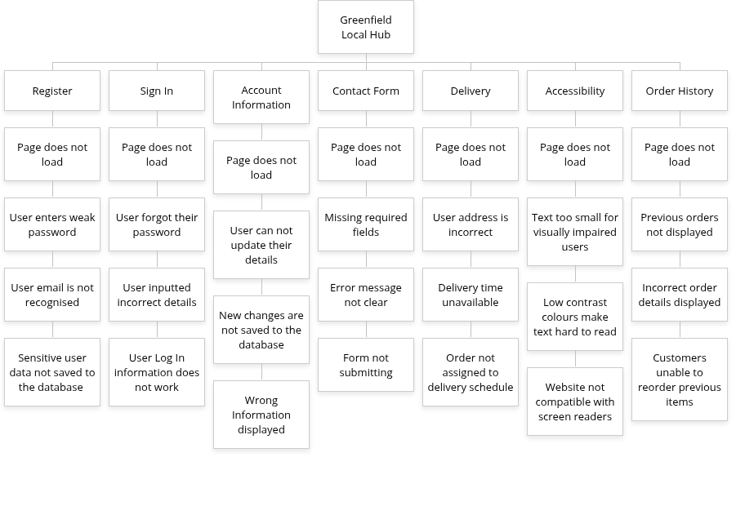

UI Considerations
The digital solution for Greenfield Local Hub must be developed in a professional way for it to represent the business well. The solution must be usable, visually appealing and industry standard. For the user to have a seamless experience the user interface must be modern and clean without too much information on the pages which could lead to confused users. For the designing phase I have considered some key aspects which are the colour scheme, images, fonts and spacing. First of all, the colour scheme I am planning to use is clean, industry standard and is connected to nature. The main colours I am using are dark green, white/cream, and a dark charcoal/brown colour.

Security Considerations & Risk Mitigation

Risk Matrix

High | R4 | R3 | R2 | R1
Significant |  |  | R6 | R5
Moderate
Low
 | Low | Moderate | Significant | High

R1
R2
R3
R4
R5
R6

Legal and Regulatory Guidelines

Legislation | Application
GDPR / Data Protection Act 2018
Consumer Rights Act 2015
Consumer Protection from Unfair Trading Regulations 2008
Electronic Commerce (EC Directive) Regulations 2002
Equality Act 2010 & Accessibility Standards WCAG
General Food Law
Food Information Regulations 2014

